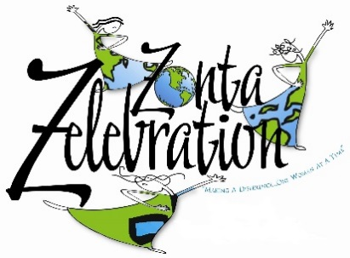
Annual Charity Clay Sport Shooting Event
Sat. February 9, 2019

REGISTRATION FORM

YES, I want to support Zonta Club of Houston Educational and Charitable Fund’s (ZCHECF) Sport Clay Shooting Event:

Name:______________________________ ___ # Of Individual Shooters @ $130

Address:____________________________ ___ # Of Teams -Five Shooters@ $600

City: ______________________ St: _____ Zip: ________________

Email Address: ______________________ ___ # Of Non-Shooter Lunches @ $25 ea.

Phone: _____________________________ ___ # Of Supporter Signs @ $_________

___ Count me in for an Underwriter Sponsorship for $__________ (enter amount)

My check payable to ZCHECF is enclosed

Please Charge my AMEX MC VISA DISCOVER

Acct #__________________________________

Exp Date _________ Validation Code _____

If Name on card or Billing address is different from above:

Name:_______________________________________________________

Address:______________________________________________________

City: ______________________ St: _____ Zip: ________________

Mail Registration to : Zonta Club of Houston Educational and Charitable Fund (ZCHECF)
c/o Kayleen Kill
12410 Shadow Island Dr
Houston, Texas 77082

